**Traffic Violation Tracking System**

**using CCTV Cameras**

YASH PARIKH  
Computer Science and Engg. (Data Science)  
Manipal Institute of Technology, Bengaluru

Bengaluru, India  
yashparikh05@gmail.com

**ABSTRACT**

Traffic rule violations are a major cause of road accidents, congestion, and loss of life in urban environments. Manual enforcement is inefficient, error-prone, and difficult to scale. This paper presents an automated traffic violation tracking system using CCTV cameras and intelligent video analysis to detect violations such as overspeeding, red-light jumping, and lane indiscipline. The system captures evidence, identifies license plates, stores violation records in a centralized database, and provides dashboards for authorities to monitor real-time traffic behavior. This solution improves transparency, reduces manual dependency, and supports data-driven traffic enforcement.

**Keywords—**

Traffic monitoring, CCTV, violation detection, license plate recognition, intelligent transportation systems.

**I. INTRODUCTION**

Rapid urbanization has significantly increased the number of vehicles on roads, leading to traffic congestion, increased violations, and rising accident rates. Traditional traffic monitoring systems rely on human police personnel, who cannot manually monitor every lane, every signal, and every violation in real time. This results in missed violations, corruption, and delays in enforcement.

To address these limitations, automated systems using CCTV, computer vision, and AI are becoming essential. Such systems reduce manual overhead, ensure fair enforcement, and operate 24/7 without fatigue or bias. This project proposes a CCTV-based violation tracking system that detects violations, identifies vehicles, and provides actionable evidence to authorities.

**II. FUNCTIONAL REQUIREMENTS**  
The system must fulfil the following functional requirements:

* **Capture and Process Footage:** Acquire and analyse CCTV video streams continuously.
* **Automated Violation Detection:** Identify traffic rule infringements accurately.
* **License Plate Recognition:** Detect and extract vehicle license plate information.
* **Evidence Capture:** Store snapshots or clips as proof of violation.
* **Database Storage:** Save violation records with time, date, and location.
* **Police Access and Reports:** Provide access for authorized personnel to view and verify violations.
* **Comprehensive Reporting:** Generate analytics and statistical reports.

**III. Non-Functional Requirements**  
The system must also meet the following quality requirements:

* **Security:** Ensure only authorized access to violation data.
* **Performance:** Process video in near real-time for quick response.
* **Usability:** Provide an intuitive and user-friendly dashboard.
* **Reliability:** Maintain 24/7 system uptime with minimal failures.
* **Scalability:** Support increasing number of cameras and data volumes.
* **Maintainability:** Allow easy debugging, enhancement, and future updates.

traffic enforcement systems automate evidence collection, improving safety and transparency. However, most systems lack integrated dashboards for authorities, real-time alerting, or centralized data storage. Our proposed system attempts to provide a complete end-to-end solution: violation detection → evidence capture → database storage → dashboard visualization.

**IV. LITERATURE REVIEW**

Existing research demonstrates the effectiveness of License Plate Recognition (LPR), YOLO-based object detection, and automated surveillance for traffic monitoring. ALPR systems have matured significantly, enabling accurate number plate extraction. Deep learning models like YOLO and RCNN provide fast and reliable vehicle detection, while recent smart traffic enforcement systems automate evidence collection, improving safety and transparency.

However, most systems lack integrated dashboards for authorities, real-time alerting, or centralized data storage. Our proposed system attempts to provide a complete end-to-end solution: violation detection → evidence capture → database storage → dashboard visualization.

**V. PROPOSED SYSTEM / METHODOLOGY**

The proposed solution includes:

* CCTV Footage Capture: Continuous video feed from surveillance cameras.
* Violation Detection Engine: Detects overspeeding, red-light jumping, and lane violations using computer vision techniques.
* License Plate Recognition: Extracts plate numbers using OCR-based LPR methods.
* Database Storage: Stores vehicle number, violation type, timestamp, and location.
* Dashboard and Alerts: Allows authorities to view violations, evidence, and statistics in real time.

**VI. SYSTEM DESIGN**

**A. Use Case Overview:**

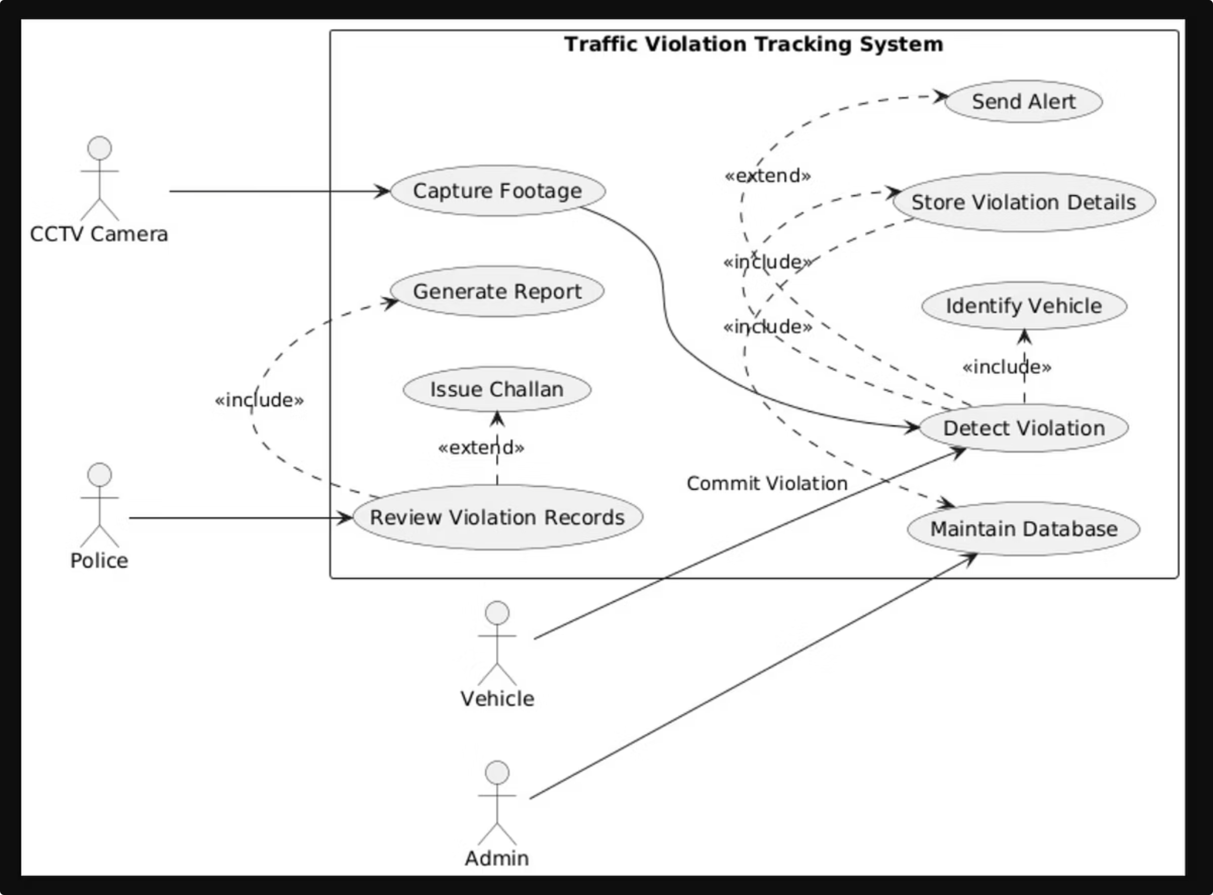

This diagram shows how different actors interact with the *Traffic Violation Tracking System*. CCTV captures footage and helps detect violations. Police review records, generate reports, and issue challans. Admin maintains the database. The system identifies vehicles, stores violation details, and sends alerts  
The use case diagrams below are individual use cases for each actor:

**Fig.1(a)**

**Fig.1(b)**

**Fig.1(c)**

**Fig.1(d)**

**B. Class Design:**

**Fig.2**

This diagram shows the *system’s structure*. Classes like Vehicle, CCTV, Violation, Police, Admin, Database, and System hold specific data and functions’ sends footage, System analyses and detects violations, and Database stores records for police and admin actions.

**C. Sequence Diagrams:**

**Fig.3(a)**

The Camera captures an image of a suspected violation. The System analyzes the image to detect the license plate and check for rule violations. Once detected, the System stores the violation details in the Database. The Officer is notified for verification and confirms the record through the system.

**Fig.3(b)**

The User accesses the Web Portal and enters their vehicle number. The Web Portal retrieves the violation details from the Database. After reviewing, the User makes the payment via the Payment Gateway. The Payment Gateway updates the Database with payment status. The Admin later verifies the transaction to ensure it’s valid

**Fig.3(c)**

The Admin requests a report through the System interface. The System queries the Database to gather violation data. The Database sends this data to the Report Module for compilation. The Report Module generates the report and displays it to the Admin.

**D. Activity Flow:**

**Fig (4)**

The Activity Diagram is a type of UML (Unified Modeling Language) behavioral diagram that represents the flow of activities or actions in a system. It is similar to a flowchart and is mainly used to model the dynamic aspects of a system

**E. Component View:**

**Fig 5(a)**

The Camera Module captures traffic footage or images. The Image Processing Service analyzes the captured media to extract license plate data. The Violation Detection Engine identifies rule violations such as speeding or red-light jumps. The Central Database stores all violation records, vehicle details, and payment information. The Admin Dashboard allows traffic officers to monitor violations and update records. The User Portal enables citizens to view and pay their fines online.

**Fif 5(b)**

The Camera Module triggers the Image Processing Unit through a capture interface. The Image Processing Unit uses a Violation Detection Engine interface to identify rule breaches. The Database stores all the violation details for future use. The Report Generator prepares daily or weekly reports for admin officers. The Payment Gateway updates the database once a fine is paid. Both Admin Dashboard and User Portal access this backend for their respective needs

**Fig 5(c)**

Client Side: Includes the User Portal for the public and Admin Dashboard for officers. Server Side: Hosts the Application Server, Database Server, Violation Detection Engine, and Payment Service. External Devices: Represent the Traffic Cameras capturing images in real time. The Application Server acts as a bridge between users and backend systems. Data flows from Traffic Cameras → Detection Engine → Database → Frontend Interfaces

**F. Collaboration/communication View:**

**Fig 6(a)**

The User uses the Web Portal to search for their violation record. The Web Portal retrieves violation details from the Database. The user initiates a transaction through the Payment Gateway. Once the payment succeeds, the Database updates the payment status. The Admin can verify or approve payments through the system.

**Fig 6(b)**

The Admin requests a report through the System. The System queries the Database for stored violation data. The Database passes the retrieved data to the Report Generator. The Report Generator prepares a summarized report and sends it back to the Admin for review.

**Fig 6(c)**

The Camera captures an image of a vehicle violating traffic rules. The System receives the image and detects the license plate. It then communicates with the Database to store the violation details. The Officer is notified by the database or system for manual verification. Once confirmed, the violation record is finalized.

**VII. RESULTS AND DISCUSSION**

**A. Traffic Monitoring Dashboard**  
The dashboard provides a centralized view of all active traffic cameras and violations detected across monitored intersections. It displays summarized analytics such as total violations, peak timing, and violation categories in a visual format to support quick decision-making by authorities. The dashboard enables administrators to track real-time road behaviour and assess traffic conditions at a glance. By presenting data in a structured and interactive manner, the system supports efficient monitoring and timely intervention for traffic enforcement.

**B. Live Violation Feed**  
The live feed section shows real-time violation events including vehicle number, violation type, timestamp, and camera location. As each new violation is detected, it is immediately logged and displayed for review, ensuring no incident goes unnoticed. This feature enables rapid verification and minimizes delays commonly associated with manual reporting. Authorities can track multiple incidents simultaneously, improving situational awareness and responsiveness.

**C. Camera Monitor Grid**  
The camera monitoring grid offers a multi-view layout where authorities can observe several CCTV points at once. Each camera feed is displayed in a structured grid format, helping the operator monitor multiple junctions in parallel without switching screens. This improves the coverage and effectiveness of surveillance activities. The grid structure also helps identify hotspots where violations occur frequently, assisting in better deployment of resources such as patrol units.

**D. Navigation Panel**  
The navigation panel allows users to move seamlessly across different system modules, including dashboard, live feed, history, and violation reports. Its structured design ensures that operators can quickly access required features without confusion or delay. By improving user experience, the navigation system reduces training time and promotes faster response actions. This increases the overall efficiency of traffic monitoring and violation handling workflows.

**E. View Violation Details Web Interface**  
This module provides detailed insights for each recorded violation, including vehicle information, violation snapshot, location, date, and time. Additional data such as violation status and officer remarks can also be displayed, offering full transparency in the enforcement process. This interface simplifies the verification and documentation process for authorities. By ensuring every violation is recorded with supporting evidence, the system maintains accountability and strengthens the fairness of traffic enforcement.

**VIII. CONCLUSION AND FUTURE SCOPE**

This system automates traffic violation monitoring, reduces manual effort, and enables transparent enforcement. Future enhancements may include automatic fine generation, integration with RTO databases, AI-based driver behavior analysis, and predictive analytics. Scalability, privacy, and legal compliance are important considerations for real-world deployment.

**IX . ACKNOWLEDGMENT**

I want to sincerely thank Dr. Ashwitha, my project supervisor, for all of her help, support, and encouragement during this project. Her knowledge and perceptions were crucial to this project's successful conclusion. I also want to express my gratitude to the Manipal Institute of Technology's Department of Computer Science & Engineering faculty for offering the required materials and a positive learning atmosphere. Without their constant support and encouragement, this project would not have been feasible

**. REFERENCES**

[1] S. Du, M. Ibrahim, M. Shehata and W. Badawy, “Automatic License Plate Recognition (ALPR): A State-of-the-Art Review,” IEEE Transactions on Circuits and Systems for Video Technology, vol. 23, no. 2, pp. 311–325, 2013.

[2] J. Redmon and A. Farhadi, “YOLOv3: An Incremental Improvement,” arXiv preprint arXiv:1804.02767, 2018.

[3] P. Viola and M. Jones, “Rapid Object Detection using a Boosted Cascade of Simple Features,” Proceedings of the IEEE Conference on Computer Vision and Pattern Recognition (CVPR), 2001.

[4] M. Sarfraz, M. Jameel and S. Hussain, “Intelligent Traffic Monitoring System for Urban Roads,” IEEE International Conference on Machine Vision, 2017.

[5] R. Girshick, “Fast R-CNN,” Proceedings of the IEEE Conference on Computer Vision and Pattern Recognition (CVPR), 2015.

[6] S. Wang et al., “Smart Traffic Management System for Real-Time Traffic Control,” IEEE Access, vol. 7, pp. 18955–18967, 2019.

[7] M. Asif, F. A. Qureshi, and S. Ahmed, “IoT Based Smart Traffic Monitoring System Using Computer Vision,” International Conference on IoT and Cloud Computing, 2022.

[8] K. Tran and R. L. Hsu, “Automatic Violation Detection for Traffic Surveillance,” IEEE International Conference on Intelligent Transportation Systems (ITSC), 2019.